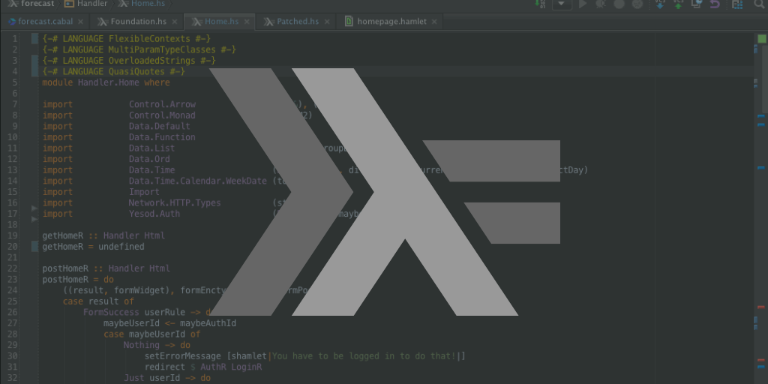

**C S3490-101_PROGRAMMING LANGUAGES Final Project Report**

Jacob Villemagne, Luke Patterson, Wolfe Bowman

**Overview**

This is the Project Report for our groups Programing Languages Final Project. The group of students that worked on this project consist of Luke Patterson, Wolfe Bowman, and Jacob Villemagne. The Project that we decided to work on was a Haskell code translator that translates Java code to C code. This project was completed in three separate phases, project proposal, project outline, and final project completion.

This report will consist of a description of our project, what it does and how it works. Along with a detailed description of the research that went into the development of the project and a discussion of what were the most difficult parts of the project.

**Table of contents**

* Project Description
* Project Research
* Project Discussion
* Conclusion

**Project Description**

**Initial Description**

For our Programming Languages Final Project our group decided to do project idea 2.4 translating from one programming language into another. The different types of code that we are going to be translating from is Java code to C code.

**User Interface**

The idea for how our user interface works is that the user initiates out program, our program askes our user for an input, after the user provides our program with a input our program reads the users input and provides an output based on the input received from the user.

The way we executed this in our program is that we set up a main method that once executes askes the user to provide our program with a Java file. Due to the complexity of this project our program will only accept Java programs formatted very specifically for our program (see Java file specification to see how and why we formatted our java files the way we did). Once the user provides our program with a acceptable Java file our program reads in the Java file and begins to translate that Java file into C code. Once our program is finished and the Java code is translated to C code our program will provide the user with a new C file of the translated Java code.

**Java File Specifications**

Our program can will only accept Java file formatted specifically for our program, this is due to how vast and complicated Java is as a programming language. We did not have enough time to make a project that could translate all of Java, just very specific Java files.

Our Java files are formatted accordingly:

* Class
  + Fields
  + Constructor
  + Methods
    - Getters for the fields
    - Setters for the fields
  + Main method

The files that we can translate are very simple files, for our main example we created a file called student.java. Student.java consisted of two fields, student & age, getters & setter for said fields, and a main method that creates three students and applies the getters and setters to alter the names and ages of the created students. Then we printed out our changes to the students.

For example, we created three students, Jacob, Luke, and Wolfe. We set Jacob’s name & age to “Jacob” and “100”, we set Luke’s name & age to “Luke” and “2”, and we set Wolfe’s name & age to “Wolfe” and “999”.

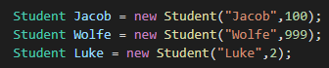

After creating our students we took our student Jacob and used the setAge method to alter his age to the age of Wolfe minus the age of Luke.



Which when printed out should be 999 – 2 = 997.

**Translating from Java to C**

This is how we translated the code from Java to C

**The Programs Output**

This is how out output is formatted and what it is expected to do……..

**Program organization**

This is how our project is organized……….

**Project Research**

Research was a vital part of finishing this project, none of use had any prior experience with building a code translator so we all had to commit to researching how it would be possible to bring our project idea to life. Our research was broken into two parts, the first part is the online research that we did, and the next was our help session research we did asking our professor for help and collaborating with him to get some ideas on how to complete this project.

**Online Research**

This is what we did…….

**Help session research**

In our live help session our group meet with our professor Doctor Andrew Polonsky, and discussed ways to

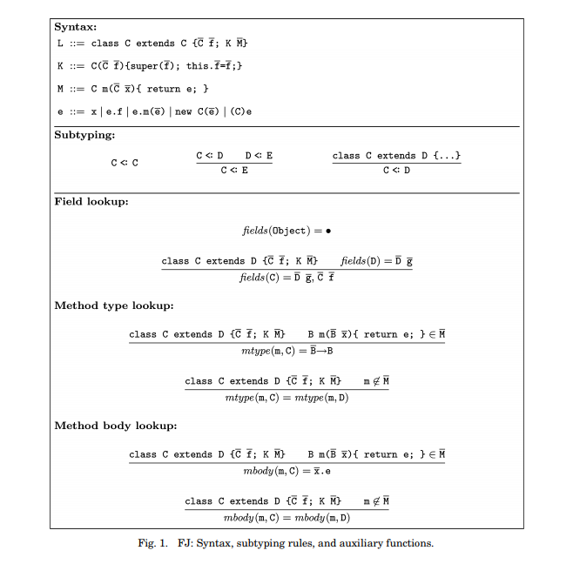

**Project Discussion**

This was the hardest part of the project……..

**Conclusion**

Yo